**CS 492**

**Senior Design Project**

**2021 Spring**



**Low-Level Design Report**

**PolliVidis**

Ömer Ünlüsoy - 21702136

Elif Gamze Güliter - 21802870

İrem Tekin - 21803267

Ece Ünal - 21703149

Umut Ada Yürüten - 21802410

**Supervisor**: Ercüment Çiçek

**Jury Members**: Shervin Arashloo and Hamdi Dibeklioglu

This report is submitted to the Department of Computer Engineering of Bilkent University in partial fulfillment of the requirements of the Senior Design Project course CS491/2.

Table of Contents

1. Introduction 3

1.1 Object Design Trade-offs 3

1.1.1 Security vs Efficiency 3

1.1.2 Functionality vs Usability 3

1.1.3 Compatibility vs Cost 4

1.1.4 Speed vs Functionality 4

1.2 Interface Documentation Guidelines 1

1.3 Engineering Standards 1

1.4 Definitions, Acronyms, and Abbreviations 2

2. Packages 3

2.0 Introduction 3

2.1 Client 5

2.1.1 Presentation Tier 5

2.2 Server 7

2.2.1 Logic Tier 7

2.2.2 Data Tier 12

3. Class Interfaces 14

3.0 Introduction 14

3.1 Client 14

3.1.1 Presentation Tier 14

3.2 Server 20

3.2.1 Logic Tier 20

3.2.2 Data Tier 32

4. Extraction Process 38

5. References 39

# 1. Introduction

Currently, the process of identifying a pollen is considered as a tedious job since it must be done manually. Since the samples of pollen are collected manually an image requires manual labor to process. Furthermore, identifying pollen from irrelevant noise or content as well as distinguishing pollen variants from one another must be done through trained eyes, which itself is an inconvenient job. Additionally, training new students to identify pollens requires further effort, especially distinguishing pollens with similar granular cell structures.

Fortunately, along with the developments in machine learning, most systems are transforming into automated models. The advancements of image processing and image classification highly inspires an automated system that could improve the manual process of pollen classification. Although there have been attempts to create such a machine learning model in order to identify pollen in a given data, currently there is no widely available model to identify pollen types for palynology, the branch of biology which examines pollen. Hence, we aim to develop a system that can fill the role of a publicly available web application for pollen identification in Turkey which would help academics to easily classify the pollen they research. Furthermore, this application would aid students trying to learn the details of palynology. PolliVidis would allow users to easily upload an image to the web application and get the results. Apart from being widely accessible, PolliVidis also aims to create a database for palynologists to share pollen data across the country.

## 1.1 Object Design Trade-offs

### 1.1.1 Security vs Efficiency

Since using hashing algorithms to store passwords needs extra time for calculations, it may cause delay in the system’s response time. However, 200 milliseconds of response time, which is the maximum response time recommended by Google [1], is decided for this process. Hence, we aim to have an optimal balance between security and efficiency.

### 1.1.2 Functionality vs Usability

Ease of use is one of the main concerns while designing the front-end of the application. It can be said that front-end design favors usability over functionality, however, it is important to note that our main functionality is related to classification and counting of the pollen samples, and it will not be affected by the decision of choosing usability over functionality.

### 1.1.3 Compatibility vs Cost

PolliVidis is a web-based application which will be working on with the most popular four web browsers which are Google Chrome, Safari, Microsoft Edge and Mozilla Firefox [2]. To increase the compatibility, it is considered developing a mobile application, however, it would increase the cost and it is decided that web application offers enough compatibility.

### 1.1.4 Speed vs Functionality

The functionality of the ML model will be favored over the response speed of the system since one of the main aims of the system is to help academics by classifying the pollen species and count pollen with accurate results.

## 1.2 Interface Documentation Guidelines

The following template is used for each class definition in this report. The class name and the description are stated first, then the attributes of the class are given and finally methods of the class are explained.

|  |  |
| --- | --- |
| **Class Name** | |
| Class Description | |
| **Attributes** | |
| Attribute Type : Attribute Name | |
| **Methods** | |
| MethodName (Parameters) : Return Type | Method Description |

## 1.3 Engineering Standards

Low Level Design Report diagrams follow the UML guidelines [3] as the previous reports of PolliVidis.

Until this report; PolliVidis has used UML Use Case Diagram to describe user interactions with the web application [4], UML Sequence Diagram to describe the lifeline of an object [5], UML Activity Diagram to describe the control flow of the system [6], and UML Deployment Diagram to define the hardware communication of the system [7].

In the Low-Level Design Report, PolliVidis uses UML Class Diagram to describe statically the structure of the system [8]. As the usage of UML is standard in the industry, all diagrams follow the UML guidelines.

For the citations in the reports, IEEE Citation guidelines are followed as it is the standard in engineering [9].

## 1.4 Definitions, Acronyms, and Abbreviations

**Palynology**: Branch of biology studying pollen.

**Academic:** User with a pollen or biology related background such as palynologists, biologists, and palynology or biology students.

**Allergenic Pollen**: Specific pollen types that humans can develop allergies to.

**Sample / Pollen Sample**: Pollen image shot by a light microscope containing a few pollen.

**Noise**: All other shapes in the sample rather than pollen itself such as spores.

**Sample Analysis**: Procedure of identifying pollen types, classification, from a sample using machine learning.

**Analysis Report**: Report containing pollen information generated by the pollen analysis.

**Pollen Map**: Google Maps supported map showing pollen information and distribution of Turkey.

**Pollen Extraction**: Process of extracting a single pollen image from the sample with few pollens using the Pollen Extraction Algorithm coded by us.

**(Ankara) Dataset**: Pollen dataset, collection of pollen images, created by us in Ankara University.

**PolliVidis Database**: MySQL based database to store all (allowed) uploaded pollen samples with their analyses in order to construct the Pollen Map.

**CNN**: Convolutional Neural Networks

**Transfer Learning**: Using pre-trained networks such as AlexNet or VGG-19 to boost the classification.

**Data Augmentation**: Manipulating dataset to avoid overfitting and increasing accuracy.

**Google Maps API**: used API for the Pollen Map of PolliVidis.

**Django**: Python package for website backend.

**React**: JavaScript library for website frontend.

**MySQL**: Relational database management system for SQL.

**PyTorch**: Python package for Machine Learning and Deep Learning.

# 2. Packages

## 2.0 Introduction

PolliVidis takes advantage of some external packages, libraries, which allow the system to be more dynamic and optimized while taking away the burden to code everything from scratch.

The first and the most significant package PolliVidis uses is PyTorch [10]. This package is a machine learning package developed by Facebook, allowing its users to construct and train neural networks easily. PolliVidis will use this package to architect its CNN and train it with the dataset we created.

The second package is SCikit-Image which PolliVidis uses for pollen extraction from sample images. It is basically an image processing toolbox [11].

For the frontend, PolliVidis uses React Library [12]. React is a JavaScript library for building user interfaces easily.

To connect the UI with the database and ML model, PolliVidis has taken advantage of the Django framework which allows its users to create web apps and connect them with their server [13].

Lastly, Google Maps API is used for PolliVidis Pollen Map [14]. This API allowed us to construct and modify a web app in PolliVidis website.

After explaining the external packages used, let’s see the internal structure of the web app. PolliVidis mimics 3-Tier Client/Server Architecture.

On the client side, the system implements the Presentation Tier which contains the UI Subsystem. This subsystem is implemented with React and manages UI components. This subsystem sends queries to the server to handle user requests and shows the results of the queries to the user.

On the server side of the system, the system implements Logic and Data Tiers. In the Logic Tier, there are two subsystems, namely Backend Subsystem and ML Subsystem. Backend Subsystem is implemented with the Python Django Framework. It directs queries coming from the client side to the Data Tier and handles user requests. This subsystem uses the ML Subsystem to extract pollen images from the sample image and analyze them one by one. It returns the analyses to the user.

ML Subsystem is the core of PolliVidis and implements two main functionalities, pollen extraction from the sample image and pollen classification with PyTorch. The classification is done by a CNN and pollen extraction uses Image Processing with the SCikit-Image package.

In the Logic Tier, a single subsystem named Database Subsystem handles database interactions of PolliVidis. It implements the MySQL database and all queries within it and supplies Python Model classes for ease of use.

## 2.1 Client

### 2.1.1 Presentation Tier

#### 2.1.1.1 UI Subsystem

UI Subsystem consists of user interface front-end views.

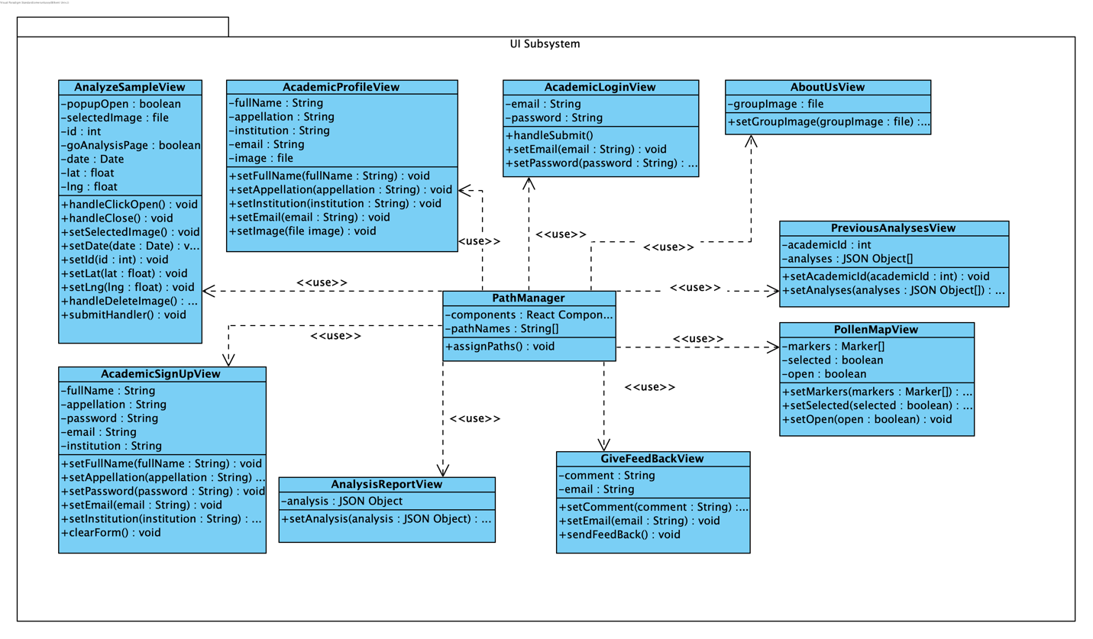

Figure : UI Subsystem

**2.1.1.1.1 Path Manager**

Path Manager handles the navigation and main structure of the frontend. It controls the presentation tier.

**2.1.1.1.2 AnalyzeSampleView**

AnalyzeSampleView handles the user interface of the screen in which users upload sample images and request an analysis.

**2.1.1.1.3 AnalysisReportView**

AnalysisReportView handles the user interface of the screen in which the analysis report of the users’ samples is shown.

**2.1.1.1.4 PollenMapView**

PollenMapView handles the user interface of the Google Maps pollen map which contains the pollen analyses as markers. When clicked on one, the analysis report of the analysis is shown.

**2.1.1.1.5 PreviousAnalysisView**

PreviousAnalysisView handles the user interface of the screen in which an academic’s previous analysis reports are shown.

**2.1.1.1.6 AcademicLoginView**

AcademicLoginView handles the user interface of the screen in which an academic can login.

**2.1.1.1.7 AcademicSignUpView**

AcademicSignUpView handles the user interface of the screen in which a user can sign up as an academic.

**2.1.1.1.8 AcademicProfileView**

AcademicProfileView handles the user interface of the screen that shows the profile information of an academic.

**2.1.1.1.9 AboutUsView**

AboutUsView handles the user interface of the screen that shows PolliVidis developers’ information.

**2.1.1.1.10 GiveFeedBackView**

GiveFeedBackView handles the user interface of the screen in which users can send feedback about PolliVidis.

## 2.2 Server

### 2.2.1 Logic Tier

#### 2.2.1.1 Backend Subsystem

Backend Subsystem mainly consists of firstly model objects used both in data and client level, secondly the serializer classes of the model objects for Http responses to the front end, and lastly the handler classes that process the request and respond accordingly.

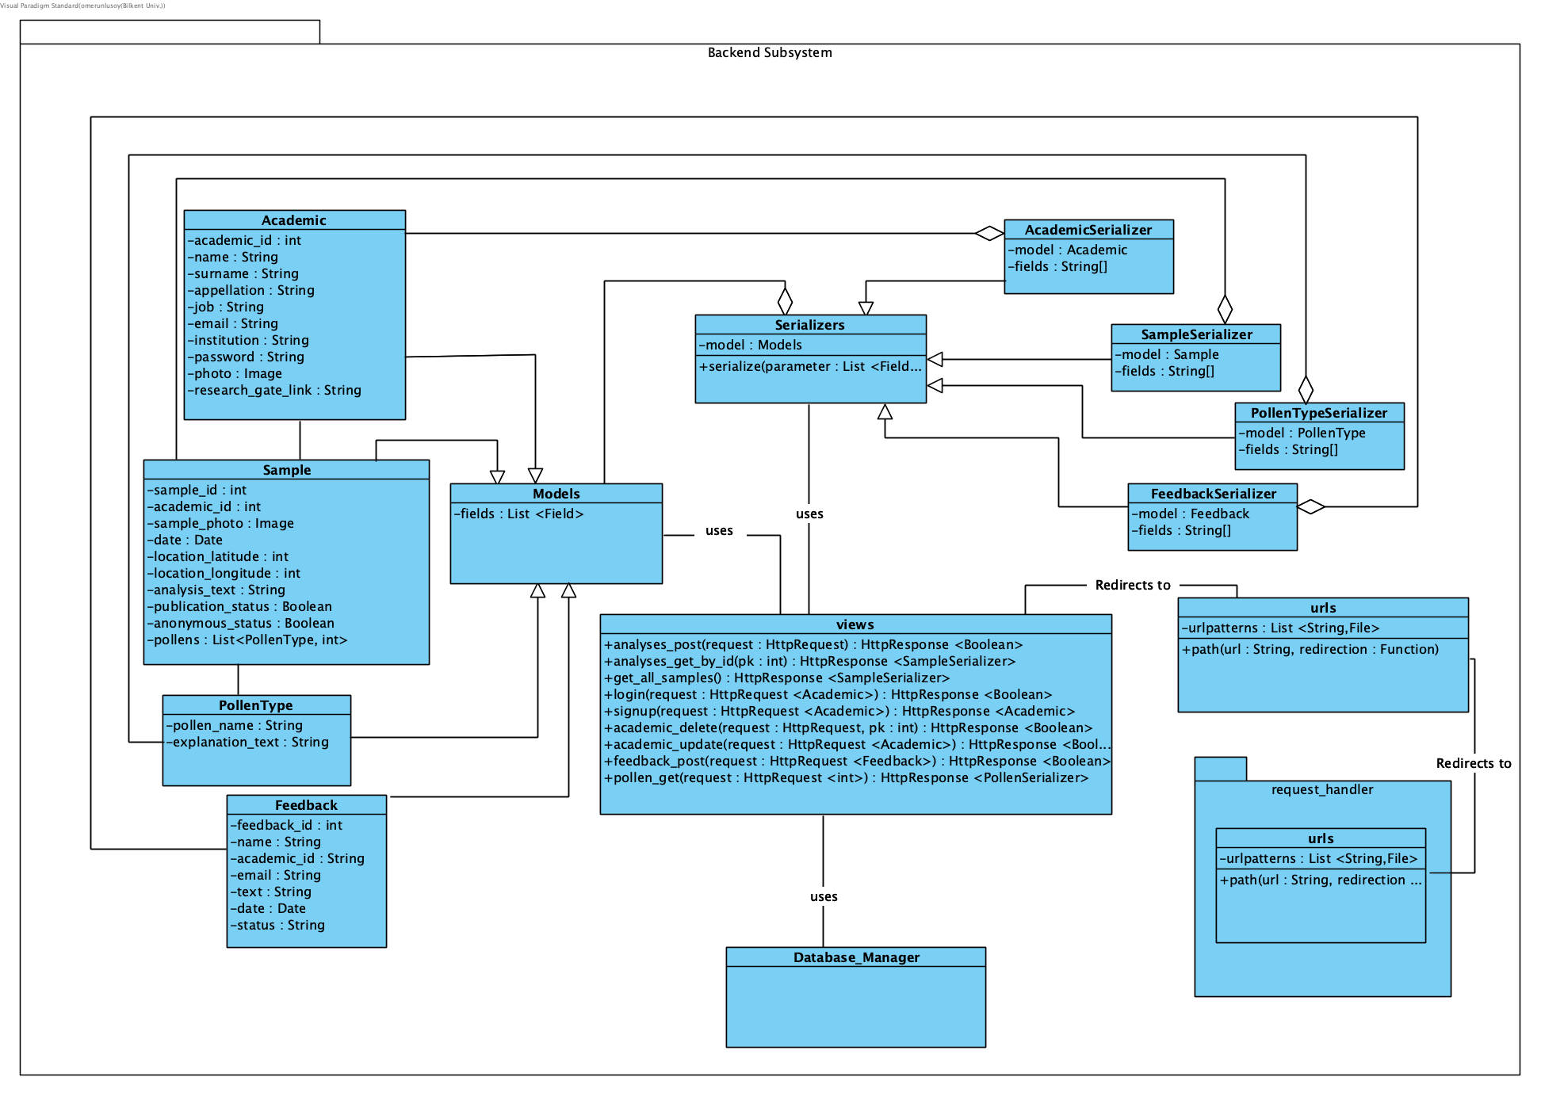

Figure : Backend Subsystem

**2.2.1.1.1 Academic**

Contains the class of Academic model which has been used both in client and data level. It is used for keeping consistency in all levels as well as defining the Http response for the client side.

**2.2.1.1.2 Sample**

Contains the class of Sample model which has been used both in client and data level. It is used for keeping consistency in all levels as well as defining the Http response for the client side.

**2.2.1.1.3 PollenType**

Contains the class of PollenType model which has been used both in client and data level. It is used for keeping consistency in all levels as well as defining the Http response for the client side.

**2.2.1.1.4 Feedback**

Contains the class of Feedback model which has been used both in client and data level. It is used for keeping consistency in all levels as well as defining the Http response for the client side.

**2.2.1.1.5 Models**

Contains the general class for models that is recognized by the REST django API.

**2.2.1.1.6 AcademicSerializer**

Contains a serializable version of the Academic class which is used to convert the Academic objects into proper Http Response bodies.

**2.2.1.1.7 SampleSerializer**

Contains a serializable version of the Sample class which is used to convert the Academic objects into proper Http Response bodies.

**2.2.1.1.8 PollenTypeSerializer**

Contains a serializable version of the PollenTypeclass which is used to convert the Academic objects into proper Http Response bodies.

**2.2.1.1.9 FeedbackSerializer**

Contains a serializable version of the Feedback class which is used to convert the Academic objects into proper Http Response bodies.

**2.2.1.1.10 Serializer**

Contains the general class for serializer classes that is recognized by the REST django API.

**2.2.1.1.11 request_handler.urls**

This class handles requests that arrive from the client side of the project. This class maps the given url to the respective handler, and redirects to that file. Although most of the requests are directed to the main API, this handler allows debugging via redirecting to admin pages. Furthermore, this file could be expanded to include different types of requests from different types of users.

**2.2.1.1.12 urls**

Much like the request_handler package in 2.2.1.1.11, this class maps request urls. However, unlike its counterpart, this url handler maps the Http requests to their respective functions in views file as it is explained in 2.2.1.1.13.

**2.2.1.1.13 views**

This class is the central part of the backend subsystem and contains functions that handles, processes and responds to the requests made by the client level. As explained in 2.2.1.1.12, urls class redirects a request to a proper function in this class. In each function, the request is transformed and acknowledged with proper Model classes. Next, methods from Database_Manager are used for database operations. Details of the Database_Manager are further explained in 2.2.2.1, hence it is represented as a blackbox class. After acquiring the results from the database, an HttpResponse is formed via Serializer classes and then sent back to client side.

#### 

#### 2.2.1.2 ML Subsystem

ML Subsystem has two main functionalities; pollen classification with PyTorch and pollen image extraction from the incoming sample image.

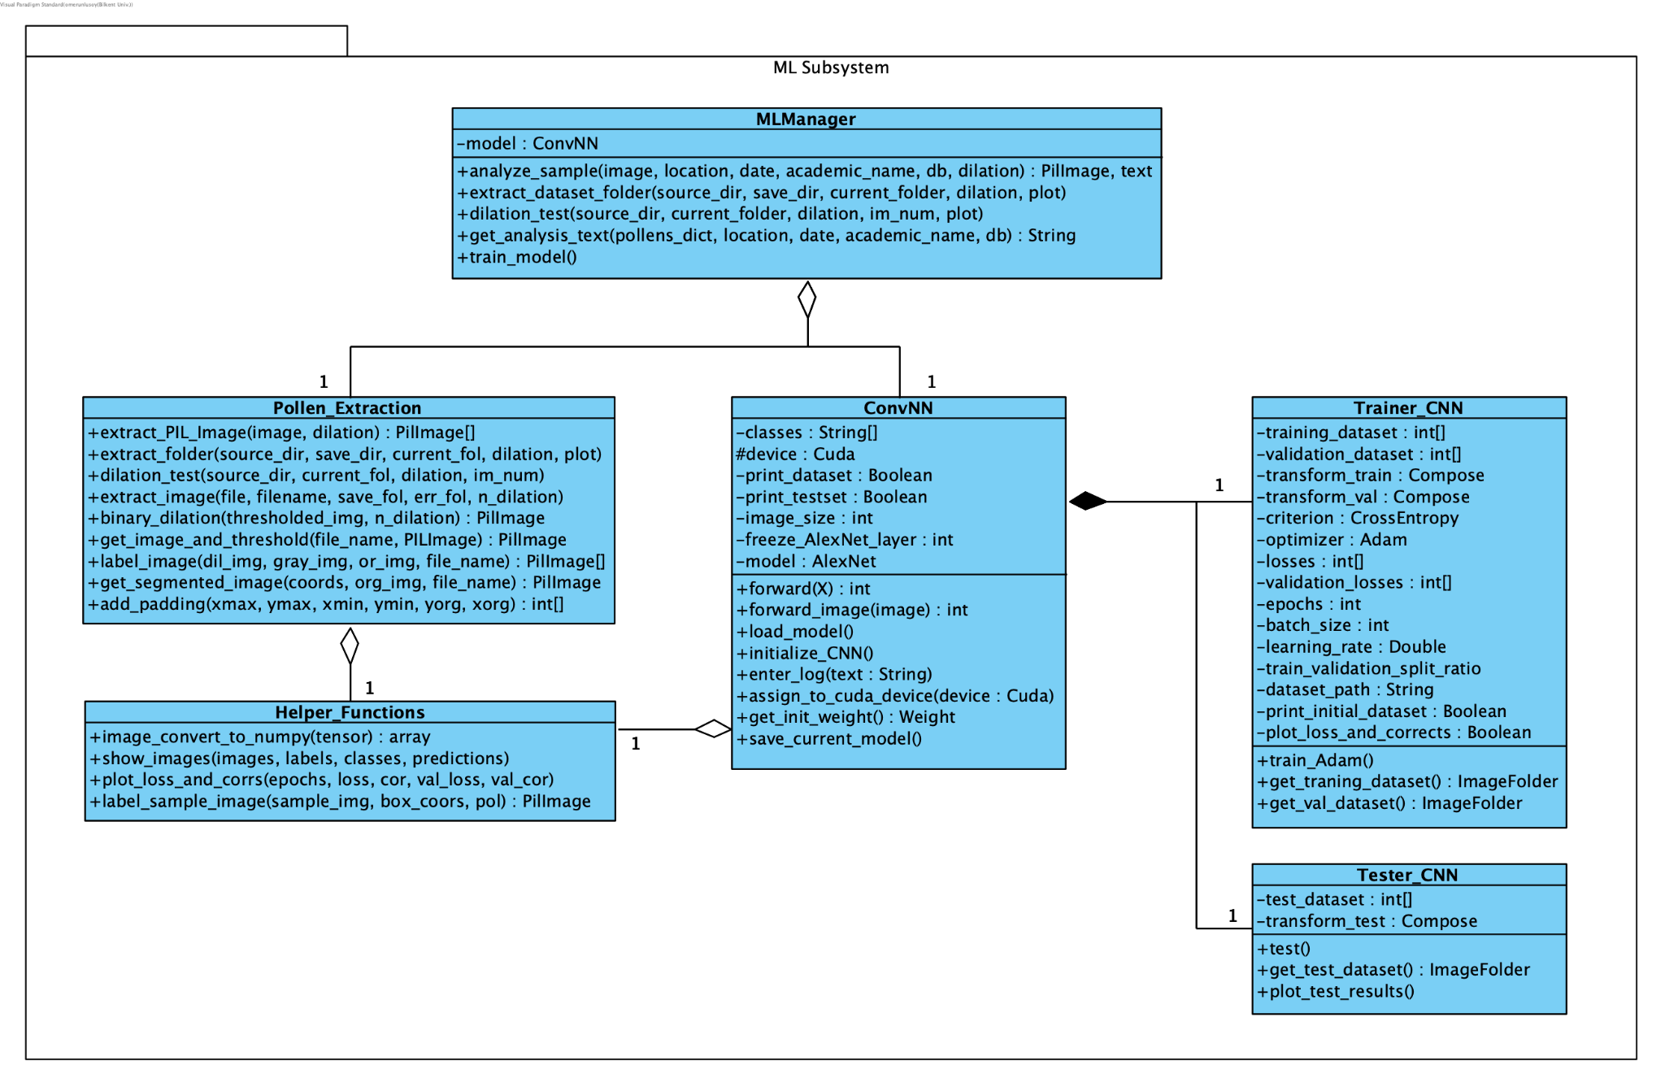

Figure : ML Subsystem

**2.2.1.2.1 ML Manager**

ML Manager class is the driver class of this subsystem, it uses Pollen Extraction and ConvNN classes to respond to a client request. Thus, it handles the two main functionalities of this subsystem, namely pollen classification and pollen image extraction. This manager class holds the trained model and uses ConvNN class to predict and classify the incoming pollens from the client. Moreover, it processes the sample image and extracts pollen images using the Pollen Extraction class.

**2.2.1.2.2 Pollen Extraction**

This class implements the pollen extraction algorithm, using image processing and dilation with Python SCikit-Image package. This extraction algorithm is used in two scenarios; when the pollen dataset of PolliVidis is prepared and ready to be pre-processed before going into the training algorithm, and when the client sends a sample image with a few pollens in it required to be pre-processed before the classification. Thus, this class can process a single image and folders of images at the same time. The procedure of this algorithm is explained in detail in another section of this report.

**2.2.1.2.3 ConvNN**

ConvNN is the class of the ML model which implements the Convolutional Neural Network. This class holds the hyperparameters of the architecture, uses Trainer class to train its model, and saves the trained model for later use. The predictions of the model are made in this class.

**2.2.1.2.4 Trainer_CNN**

This class implements the training procedure of the model. The sole reason for this functionality to be implemented as a separate class is ease of use.

**2.2.1.2.5 Tester_CNN**

This class implements the testing procedure of the model and calculates the evaluation matrices.

**2.2.1.2.6 Helper_Functions**

This class is a helper class used by most classes in this subsystem. It implements general purpose functionalities such as printing, plotting, and converting images. Its implementation simplifies the subsystem.

### 

### 2.2.2 Data Tier

#### 2.2.2.1 Database Subsystem

Database Subsystem deals with the usage and the management of the database for the application.

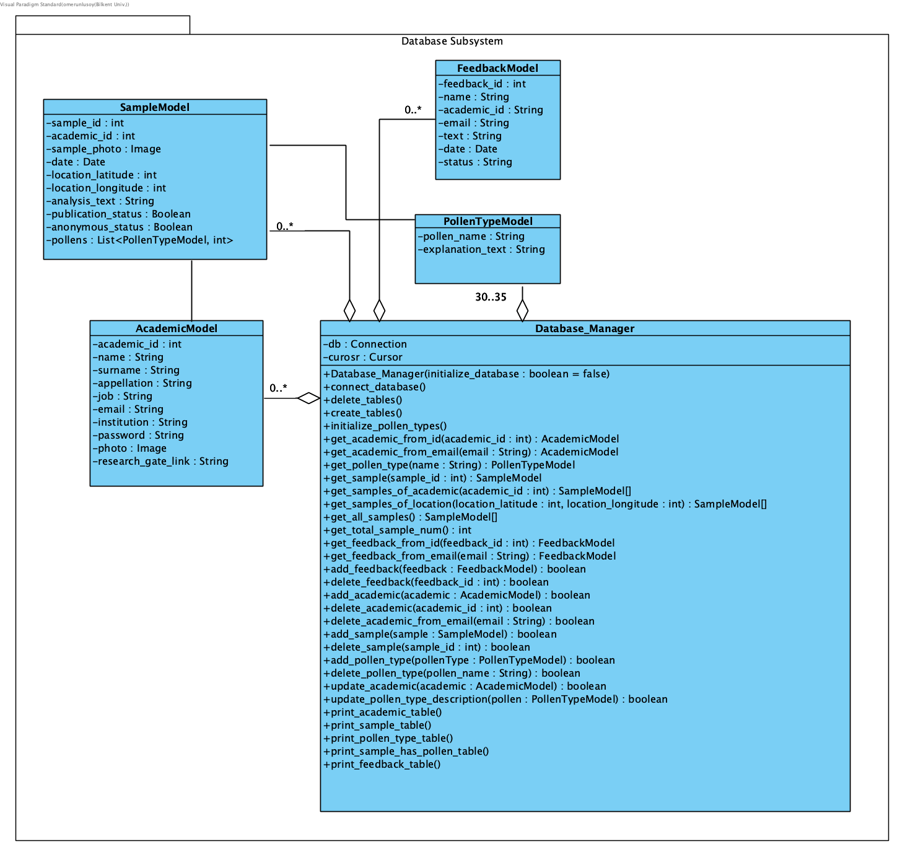

Figure : Database Subsystem

**2.2.2.1.1 AcademicModel**

Contains the class of AcademicModel, which has been used both in client and data level. It is used to acknowledge the data received from the backend as well as sent and acquired from the database.

**2.2.2.1.2 SampleModel**

Contains the class of SampleModel, which has been used both in client and data level. It is used to acknowledge the data received from the backend as well as sent and acquired from the database.

**2.2.2.1.3 PollenTypeModel**

Contains the class of PollenTypeModel, which has been used both in client and data level. It is used to acknowledge the data received from the backend as well as sent and acquired from the database.

**2.2.2.1.4 FeedbackModel**

Contains the class of FeedbackModel, which has been used both in client and data level. It is used to acknowledge the data received from the backend as well as sent and acquired from the database.

**2.2.2.1.5 Database_Manager**

This class is the main processor of the Database Subsystem. It is used to connect to the database, initialize it and then execute commands for utilizing the database. It uses other Model classes to send and receive data from the database, in which the tables correspond with the model objects.

# 

# 3. Class Interfaces

## 3.0 Introduction

In the Class Interfaces section, attributes and methods of each class will be given with the method signatures and detailed explanations.

## 3.1 Client

### 3.1.1 Presentation Tier

#### 3.1.1.1 UI Subsystem

|  |  |
| --- | --- |
| **Class PathManager** |  |
| Path Manager handles the navigation and main structure of the frontend. It controls the presentation tier. | |
| **Attributes** |  |
| private React Component[] components | |
| private String[] pathNames | |
| **Methods** |  |
| void assignPaths() | Assigns paths to components (pages) |

|  |  |
| --- | --- |
| **Class AnalyzeSampleView** |  |
| AnalyzeSampleView handles the user interface of the screen in which users upload sample images and request an analysis. | |
| **Attributes** |  |
| private boolean popupOpen | |
| private file selectedImage | |
| Private int id | |
| Private boolean goAnalysisPage | |
| Private Date date | |
| Private float lng | |
| Private float lat | |
| **Methods** |  |
| void handleClickOpen() | Opens the popup screen for selecting image |
| void handleClose() | Closes the popup screen for selecting image |
| void setSelectedImage() | Sets the attribute selected image |
| void setDate(Date date) | Sets the attribute date |
| void setId(int id) | Sets the attribute id |
| void setLat(float lat) | Sets the attribute lat |
| void setLng(float lng) | Sets the attribute lng |
| Void handleDeleteImage() | Deletes the selected image, sets selected image null |
| Void submitHandler() | Sends the selected image, date, lat, lng, id to the server |

|  |  |
| --- | --- |
| **Class AnalysisReportView** |  |
| AnalysisReportView handles the user interface of the screen in which the analysis report of the users’ samples is shown. | |
| **Attributes** |  |
| Private JSON Object analysis | |
| **Methods** |  |
| void setAnalysis(JSON Object analysis) | Sets the analysis information coming from the server to the attribute analysis |

|  |  |
| --- | --- |
| **Class PollenMapView** |  |
| PollenMapView handles the user interface of the Google Maps pollen map which contains the pollen analyses as markers. When clicked on one, the analysis report of the analysis is shown. | |
| **Attributes** |  |
| Private Marker[] markers | |
| Private boolean selected | |
| Private boolean open | |
| **Methods** |  |
| Void setMarkers(Marker[] markers) | Sets the marker locations coming from the server to the markers array |
| Void setSelected(boolean selected) | Sets the attribute selected. Used when a marker is clicked by the user. |
| Void setOpen(boolean open) | Sets the attribute open. Opens a left drawer when a marker is clicked and shows analysis information corresponding to that marker. |

|  |  |
| --- | --- |
| **Class PreviousAnalysesView** |  |
| PreviousAnalysisView handles the user interface of the screen in which an academic’s previous analysis reports are shown. | |
| **Attributes** |  |
| Private int academicId | |
| Private JSON Object[] analyses | |
| **Methods** |  |
| void setAnalyses(JSON Object[] analyses) | Sets the previous analyses information coming from the server to the attribute analyses |
| Void setAcademicId(int academicId) | Sets the attribute academicId |

## 

|  |  |
| --- | --- |
| **Class AcademicLoginView** |  |
| AcademicLoginView handles the user interface of the screen in which an academic can login. | |
| **Attributes** |  |
| Private String email | |
| Private String password | |
| **Methods** |  |
| void handleSubmit() | Send email and password information to the server |
| Void setEmail(String email) | Sets the attribute email |
| Void setPassword(String password) | Sets the attribute password |

|  |  |
| --- | --- |
| **Class AcademicSignUpView** |  |
| AcademicSignUpView handles the user interface of the screen in which a user can sign up as an academic. | |
| **Attributes** |  |
| Private String fullName | |
| Private String appellation | |
| Private String password | |
| Private String email | |
| Private String institution | |
| **Methods** |  |
| void setFullName(String fullName) | Sets the attribute fullName |
| void setAppellation(String appellation) | Sets the attribute appellation |
| void setPassword(String password) | Sets the attribute password |
| void setEmail(String email) | Sets the attribute email |
| void setInstitution(String institution) | Sets the attribute institution |
| Void clearForm() | Sets all the attributes to null |

|  |  |
| --- | --- |
| **Class AcademicProfileView** |  |
| AcademicProfileView handles the user interface of the screen that shows the profile information of an academic. | |
| **Attributes** |  |
| Private String fullName | |
| Private String appellation | |
| Private file image | |
| Private String email | |
| Private String institution | |
| **Methods** |  |
| void setFullName(String fullName) | Sets the attribute fullName |
| void setAppellation(String appellation) | Sets the attribute appellation |
| void setEmail(String email) | Sets the attribute email |
| void setInstitution(String institution) | Sets the attribute institution |
| Void setImage(file image) | Sets the attribute image |

|  |  |
| --- | --- |
| **Class AboutUsView** |  |
| AboutUsView handles the user interface of the screen that shows PolliVidis developers’ information. | |
| **Attributes** |  |
| Private file groupImage | |
| **Methods** |  |
| void setGroupImage(file groupImage) | Sets the attribute groupImage |

|  |  |
| --- | --- |
| **Class GiveFeedBackView** |  |
| GiveFeedBackView handles the user interface of the screen in which users can send feedback about PolliVidis. | |
| **Attributes** |  |
| Private String comment | |
| Private String email | |
| **Methods** |  |
| void setComment(String comment) | Sets the attribute comment |
| void setEmail(String email) | Sets the attribute email |
| Void sendFeedBack() | Sends the comment and email information to the server |

## 

## 3.2 Server

### 3.2.1 Logic Tier

#### 3.2.1.1 Backend Subsystem

|  |  |
| --- | --- |
| **Class Academic** |  |
| Contains the class of Academic model which has been used both in client and data level. It is used for keeping consistency in all levels as well as defining the Http response for the client side. | |
| **Attributes** | |
| private int academic_id | |
| private String name | |
| private String surname | |
| private String appellation | |
| private String job | |
| private String mail | |
| private String institution | |
| private String password | |
| private Image photo | |
| private String research_gate_link | |

|  |  |
| --- | --- |
| **Class Sample** |  |
| Contains the class of Sample model which has been used both in client and data level. It is used for keeping consistency in all levels as well as defining the Http response for the client side. | |
| **Attributes** | |
| private int sample_id | |
| private int academic_id | |
| private Image sample_photo | |
| private Date date | |
| private int location_latitude | |
| private int location_longitude | |
| private String analysis_text | |
| private Boolean publication_status | |
| private Boolean anonymous_status | |
| private String research_gate_link | |
| private List<PollenTypeModel,int> pollens | |

|  |  |
| --- | --- |
| **Class PollenType** |  |
| Contains the class of PollenType model which has been used both in client and data level. It is used for keeping consistency in all levels as well as defining the Http response for the client side. | |
| **Attributes** | |
| private String pollen_name | |
| private String explanation_text | |

|  |  |
| --- | --- |
| **Class Feedback** |  |
| Contains the class of Feedback model which has been used both in client and data level. It is used for keeping consistency in all levels as well as defining the Http response for the client side. | |
| **Attributes** | |
| private int feedback_id | |
| private String name | |
| private int academic_id | |
| private String email | |
| private String text | |
| private Date date | |
| private String status | |

|  |  |
| --- | --- |
| **Class Models** |  |
| Contains the general class for models that is recognized by the REST django API. | |
| **Attributes** | |
| private List<Field> fields | |

|  |  |
| --- | --- |
| **Class AcademicSerializer** |  |
| Contains a serializable version of the Academic class which is used to convert the Academic objects into proper Http Response bodies. | |
| **Attributes** | |
| private Academic model | |
| private String[] fields | |

|  |  |
| --- | --- |
| **Class SampleSerializer** |  |
| Contains a serializable version of the Sample class which is used to convert the Academic objects into proper Http Response bodies. | |
| **Attributes** | |
| private Sample model | |
| private String[] fields | |

|  |  |
| --- | --- |
| **Class PollenTypeSerializer** |  |
| Contains a serializable version of the PollenType class which is used to convert the Academic objects into proper Http Response bodies. | |
| **Attributes** | |
| private PollenType model | |
| private String[] fields | |

|  |  |
| --- | --- |
| **Class FeedbackSerializer** |  |
| Contains a serializable version of the Feedback class which is used to convert the Academic objects into proper Http Response bodies. | |
| **Attributes** | |
| private Feedback model | |
| private String[] fields | |

|  |  |
| --- | --- |
| **Class Serializer** |  |
| Contains the general class for serializer classes that is recognized by the REST django API. | |
| **Attributes** | |
| private Models model | |
| **Methods** |  |
| serialize(parameter : List <Fields>) | Serializes the given model according to the its fields |

|  |  |
| --- | --- |
| **Class request_handler.urls** |  |
| This class handles requests that arrive from the client side of the project. This class maps the given url to the respective handler, and redirects to that file. Although most of the requests are directed to the main API, this handler allows debugging via redirecting to admin pages. Furthermore, this file could be expanded to include different types of requests from different types of users. | |
| **Attributes** | |
| private List<String, File> urlpatterns | |
| **Methods** |  |
| path(url : String, redirection : File) | Redirects given string url to mapped file |

|  |  |
| --- | --- |
| **Class urls** |  |
| Much like the request_handler package in 2.2.1.1.11, this class maps request urls. However, unlike its counterpart, this url handler maps the Http requests to their respective functions in views file as it is explained in 2.2.1.1.13. | |
| **Attributes** | |
| private List<String, File> urlpatterns | |
| **Methods** |  |
| path(url : String, redirection : Function) | Redirects given string url to the mapped function |

|  |  |
| --- | --- |
| **Class views** |  |
| This class is the central part of the backend subsystem and contains functions that handles, processes and responds to the requests made by the client level. As explained in 2.2.1.1.12, urls class redirects a request to a proper function in this class. In each function, the request is transformed and acknowledged with proper Model classes. Next, methods from Database_Manager are used for database operations. Details of the Database_Manager are further explained in 2.2.2.1, hence it is represented as a blackbox class. After acquiring the results from the database, an HttpResponse is formed via Serializer classes and then sent back to the client side. | |
| **Methods** |  |
| analyses_post(request : HttpRequest) : HttpResponse <Boolean> | Inserts the given analysis to the database. Returns true if successful, otherwise false |
| analyses_get_by_id(pk : int) : HttpResponse <SampleSerializer> | Returns the analysis with the given id |
| get_all_samples() : HttpResponse <SampleSerializer> | Returns all uploaded samples from the database |
| login(request : HttpRequest <Academic>) : HttpResponse <Boolean> | Attempts to find matching Academic in the database. Returns the user if found, null otherwise. |
| signup(request : HttpRequest <Academic>) : HttpResponse <Academic> | Attempts to insert a user into the database. Returns the user if successful, null otherwise. |
| academic_delete(request : HttpRequest, pk : int) : HttpResponse <Boolean> | Attempts to remove an Academic user with the given properties. Returns true if successful, false otherwise. |
| academic_update(request : HttpRequest <Academic>) : HttpResponse <Boolean> | Changes the attributes of an Academic tuple in the database. Returns true if successful, false otherwise. |
| feedback_post(request : HttpRequest <Feedback>) : HttpResponse <Boolean> | Inserts new feedback into the database. Returns true if successful, false otherwise. |
| pollen_get(request : HttpRequest <int>) : HttpResponse <PollenSerializer> | Gets a pollen of PollenType from the database with the given parameters. Returns the pollen if successful, null otherwise. |

#### 3.2.1.2 ML Subsystem

|  |  |
| --- | --- |
| **Class ML_Manager** |  |
| ML Manager class is the driver class of this subsystem, it uses Pollen Extraction and ConvNN classes to respond to a client request. Thus, it handles the two main functionalities of this subsystem, namely pollen classification and pollen image extraction. This manager class holds the trained model and uses ConvNN class to predict and classify the incoming pollens from the client. Moreover, it processes the sample image and extracts pollen images using the Pollen Extraction class. | |
| **Attributes** | |
| private ConvNN model | |
| **Methods** |  |
| analyze_sample(image, location, date, academic_name, db, dilation) : PilImage, text | This function gets the image from the client side via backend and calls ConvNN forward function to classify each pollen after extracting them from the sample. It returns the analyzed image with the analysis text. |
| extract_dataset_folder(source_dir, save_dir, current_folder, dilation, plot) | This function calls the Pollen_Extraction class to process a dataset folder. |
| dilation_test(source_dir, current_folder, dilation, im_num, plot) | This function calls the dilation test of the extractor. |
| get_analysis_text(pollens_dict, location, date, academic_name, db) : String | This function constructs the analysis text from the classification results. |
| train_model() | This function calls the training procedure of Training_CNN. |

|  |  |
| --- | --- |
| **Class Pollen_Extraction** |  |
| This class implements the pollen extraction algorithm, using image processing and dilation with Python SCikit-Image package. This extraction algorithm is used in two scenarios; when the pollen dataset of PolliVidis is prepared and ready to be pre-processed before going into the training algorithm, and when the client sends a sample image with a few pollens in it required to be pre-processed before the classification. Thus, this class can process a single image and folders of images at the same time. The procedure of this algorithm is explained in detail in another section of this report. | |
| **Methods** |  |
| extract_PIL_Image(image, dilation) : PilImage [] | This function extracts pollens from the single given image and is used for the client sample images. |
| extract_folder(source_dir, save_dir, current_fol, dilation, plot) | This function processes the entire folder for pollen extraction for the pre-processing for the training. |
| dilation_test(source_dir, current_fol, dilation, im_num) | This function tests for the best dilation value for a given image. |
| extract_image(file, filename, save_fol, err_fol, n_dilation) | This function extracts a single image, and is called by extract_PIL_Image. |
| binary_dilation(thresholded_img, n_dilation) : PilImage | This function applies binary dilation to given image. |
| get_image_and_threshold(file_name, PILImage) : PilImage | This function loads the image from a filepath and applies thresholding to the image. |
| label_image(dil_img, gray_img, or_img, file_name) : PilImage [] | This function labels the binary thresholded image to separate regions for pollen extraction. |
| get_segmented_image(coords, org_img, file_name) : PilImage | This image applies segmentation. |
| add_padding(xmax, ymax, xmin, ymin, yorg, xorg) : int [] | This function adds padding to the segmented image before extracting it. |

|  |  |
| --- | --- |
| **Class ConvNN** |  |
| ConvNN is the class of the ML model which implements the Convolutional Neural Network. This class holds the hyperparameters of the architecture, uses Trainer class to train its model, and saves the trained model for later use. The predictions of the model are made in this class. | |
| **Attributes** |  |
| private String[]classes | |
| protected Cuda device | |
| private Boolean print_dataset | |
| private Boolean print_testset | |
| private int image_size | |
| private int freeze_AlexNet_layer | |
| private torch.AlexNet model | |
| **Methods** |  |
| forward(X) : int | This function is the classic forward method of CNN, predicts the class of the given image. |
| forward_image(image) : int | This function applies transformations before calling the forward method. |
| load_model() | This function loads the model for the later use by ML_Manager. |
| initialize_CNN() | This function is the main driver function of this class, it is a procedure of creating transformations, datasets, and calling training function. |
| enter_log(text : String) | This general function enters log to the log file. |
| assign_to_cuda_device(device : Cuda) | This function assigns each object to the Cuda. |
| get_init_weight() : NN.Weight | Returns to the initial weights of the CNN for easy convergence. |
| save_current_model() | Saves the current model. |

|  |  |
| --- | --- |
| **Class Trainer_CNN** |  |
| This class implements the training procedure of the model. The sole reason for this functionality to be implemented as a separate class is ease of use. | |
| **Attributes** |  |
| private int[] training_dataset | |
| private int[] validation_dataset | |
| private Compose transform_train | |
| private Compose transform_val | |
| private CrossEntropy criterion | |
| private optim.Adam optimizer | |
| private int[] losses | |
| private int[] validation_losses | |
| private int epochs | |
| private int batch_size | |
| private Double learning_rate | |
| private Double train_validation_split_ratio | |
| private String dataset_path | |
| private Boolean print_initial_dataset | |
| private Boolean plot_loss_and_corrects | |
| **Methods** |  |
| train_Adam() | implements the entire training procedure of the model. |
| get_traning_dataset() : ImageFolder | Returns the training set. |
| get_val_dataset() : ImageFolder | Returns the validation set. |

|  |  |
| --- | --- |
| **Class Tester_CNN** |  |
| This class implements the testing procedure of the model and calculates the evaluation matrices. | |
| **Attributes** |  |
| private int[] test_dataset | |
| private Compose transform_test | |
| **Methods** |  |
| test() | Tests the model with the test set and calculates the evaluation matrices. |
| get_test_dataset() : ImageFolder | Returns the test set. |
| plot_test_results() | Plots the evaluation metrics. |

|  |  |
| --- | --- |
| **Class Helper_Functions** |  |
| This class is a helper class used by most classes in this subsystem. It implements general purpose functionalities such as printing, plotting, and converting images. Its implementation simplifies the subsystem. | |
| **Methods** |  |
| image_convert_to_numpy(tensor) : np.array | Converts PiLImage (tensor) to the numpy array. |
| show_images(images, labels, classes, predictions) | Displays the given image. |
| plot_loss_and_corrs(epochs, loss, cor, val_loss, val_cor) | Plots the loss and corrects of the training procedure. |
| label_sample_image(sample_img, box_coors, pol) : PilImage | Draws rectangular boxes around the labeled pollens. |

### 3.2.2 Data Tier

#### 3.2.2.1 Database Subsystem

|  |  |
| --- | --- |
| **Class AcademicModel** |  |
| Contains the class of AcademicModel, which has been used both in client and data level. It is used to acknowledge the data received from the backend as well as sent and acquired from the database. | |
| **Attributes** | |
| private int academic_id | |
| private String name | |
| private String surname | |
| private String appellation | |
| private String job | |
| private String mail | |
| private String institution | |
| private String password | |
| private Image photo | |
| private String research_gate_link | |

|  |  |
| --- | --- |
| **Class SampleModel** |  |
| Contains the class of SampleModel, which has been used both in client and data level. It is used to acknowledge the data received from the backend as well as sent and acquired from the database. | |
| **Attributes** | |
| private int sample_id | |
| private int academic_id | |
| private Image sample_photo | |
| private Date date | |
| private int location_latitude | |
| private int location_longitude | |
| private String analysis_text | |
| private Boolean publication_status | |
| private Boolean anonymous_status | |
| private String research_gate_link | |
| private List<PollenTypeModel,int> pollens | |

|  |  |
| --- | --- |
| **Class PollenTypeModel** |  |
| Contains the class of PollenTypeModel, which has been used both in client and data level. It is used to acknowledge the data received from the backend as well as sent and acquired from the database. | |
| **Attributes** | |
| private String pollen_name | |
| private String explanation_text | |

|  |  |
| --- | --- |
| **Class FeedbackModel** |  |
| Contains the class of FeedbackModel, which has been used both in client and data level. It is used to acknowledge the data received from the backend as well as sent and acquired from the database. | |
| **Attributes** | |
| private int feedback_id | |
| private String name | |
| private int academic_id | |
| private String email | |
| private String text | |
| private Date date | |
| private String status | |

|  |  |
| --- | --- |
| **Class Databas_Manager** |  |
| This class is the main processor of the Database Subsystem. It is used to connect to the database, initialize it and then execute commands for utilizing the database. It uses other Model classes to send and receive data from the database, in which the tables correspond with the model objects. | |
| **Attributes** |  |
| private Connection db | |
| private Cursor cursor | |
| **Methods** |  |
| Database_Manager(initialize_database : boolean = false) | Initializes database |
| connect_database() | Connects to database. |
| delete_tables() | Drops all tables in the database. |
| create_tables() | Creates tables in the database with predetermined attributes and table names. |
| initialize_pollen_types() | Populates the pollen table with tuples. |
| get_academic_from_id(academic_id : int) : Database Subsystem.AcademicModel | Returns the academic user tuple in the database with the given id. |
| get_academic_from_email(email : String) : Database Subsystem.AcademicModel | Returns the academic user tuple in the database with the given email. |
| get_pollen_type(name : String) : Database Subsystem.PollenTypeModel | Returns the pollen with the given name in the database. |
| get_sample(sample_id : int) : Database Subsystem.SampleModel | Returns the sample tuple in the database with the given id. |
| get_samples_of_academic(academic_id : int) : Database Subsystem.SampleModel [] | Returns all the samples uploaded by the academic user with the given id. |
| get_samples_of_location(location_latitude : int, location_longitude : int) : Database Subsystem.SampleModel [] | Returns all the samples in the database with the given coordinates. |
| get_all_samples() : Database Subsystem.SampleModel [] | Return all the samples in the database. |
| get_total_sample_num() : int | Returns the number of samples in the database |
| get_feedback_from_id(feedback_id : int) : Database Subsystem.FeedbackModel | Returns the feedback tuple with the given id. |
| get_feedback_from_email(email : String) : Database Subsystem.FeedbackModel | Returns the feedback tuple with the given email. |
| add_feedback(feedback : Database Subsystem.FeedbackModel) : boolean | Creates and adds a new feedback tuple into the database. Returns true if successful, otherwise false. |
| delete_feedback(feedback_id : int) : boolean | Deletes the feedback tuple with the given id. Returns true if successful, otherwise false. |
| add_academic(academic : Database Subsystem.AcademicModel) : boolean | Creates and adds a new academic tuple into the database. Returns true if successful, otherwise false. |
| delete_academic(academic_id : int) : boolean | Deletes the academic tuple with the given id. Returns true if successful, otherwise false. |
| delete_academic_from_email(email : String) : boolean | Deletes the academic tuple with the given email. Returns true if successful, otherwise false. |
| add_sample(sample : Database Subsystem.SampleModel) : boolean | Creates and adds a new sample tuple into the database. Returns true if successful, otherwise false. |
| delete_sample(sample_id : int) : boolean | Deletes the sample tuple with the given id. Returns true if successful, otherwise false. |
| add_pollen_type(pollenType : Database Subsystem.PollenTypeModel) : boolean | Creates and adds a new pollen type tuple into the database. Returns true if successful, otherwise false. |
| delete_pollen_type(pollen_name : String) : boolean | Deletes the pollen type tuple with the given name. Returns true if successful, otherwise false. |
| update_academic(academic : Database Subsystem.AcademicModel) : boolean | Updates academic tuple with the given parameters. Returns true if successful, otherwise false. |
| update_pollen_type_description(pollen : Database Subsystem.PollenTypeModel) : boolean | Updates pollen type tuple with the given parameters. Returns true if successful, otherwise false. |
| print_academic_table() | Prints the academic table and its tuples |
| print_sample_table() | Prints the sample table and its tuples |
| print_pollen_type_table() | Prints the pollen type table and its tuples |
| print_sample_has_pollen_table() | Prints the sample_has_pollen table and its tuples |
| print_feedback_table() | Prints the feedback table and its tuples |

# 

# 4. Extraction Process

The pollen extraction from a given sample image is summarized in the following image with the gray scaling, dilation, thresholding, labeling, cropping, classification, and analyzed imaged construction.

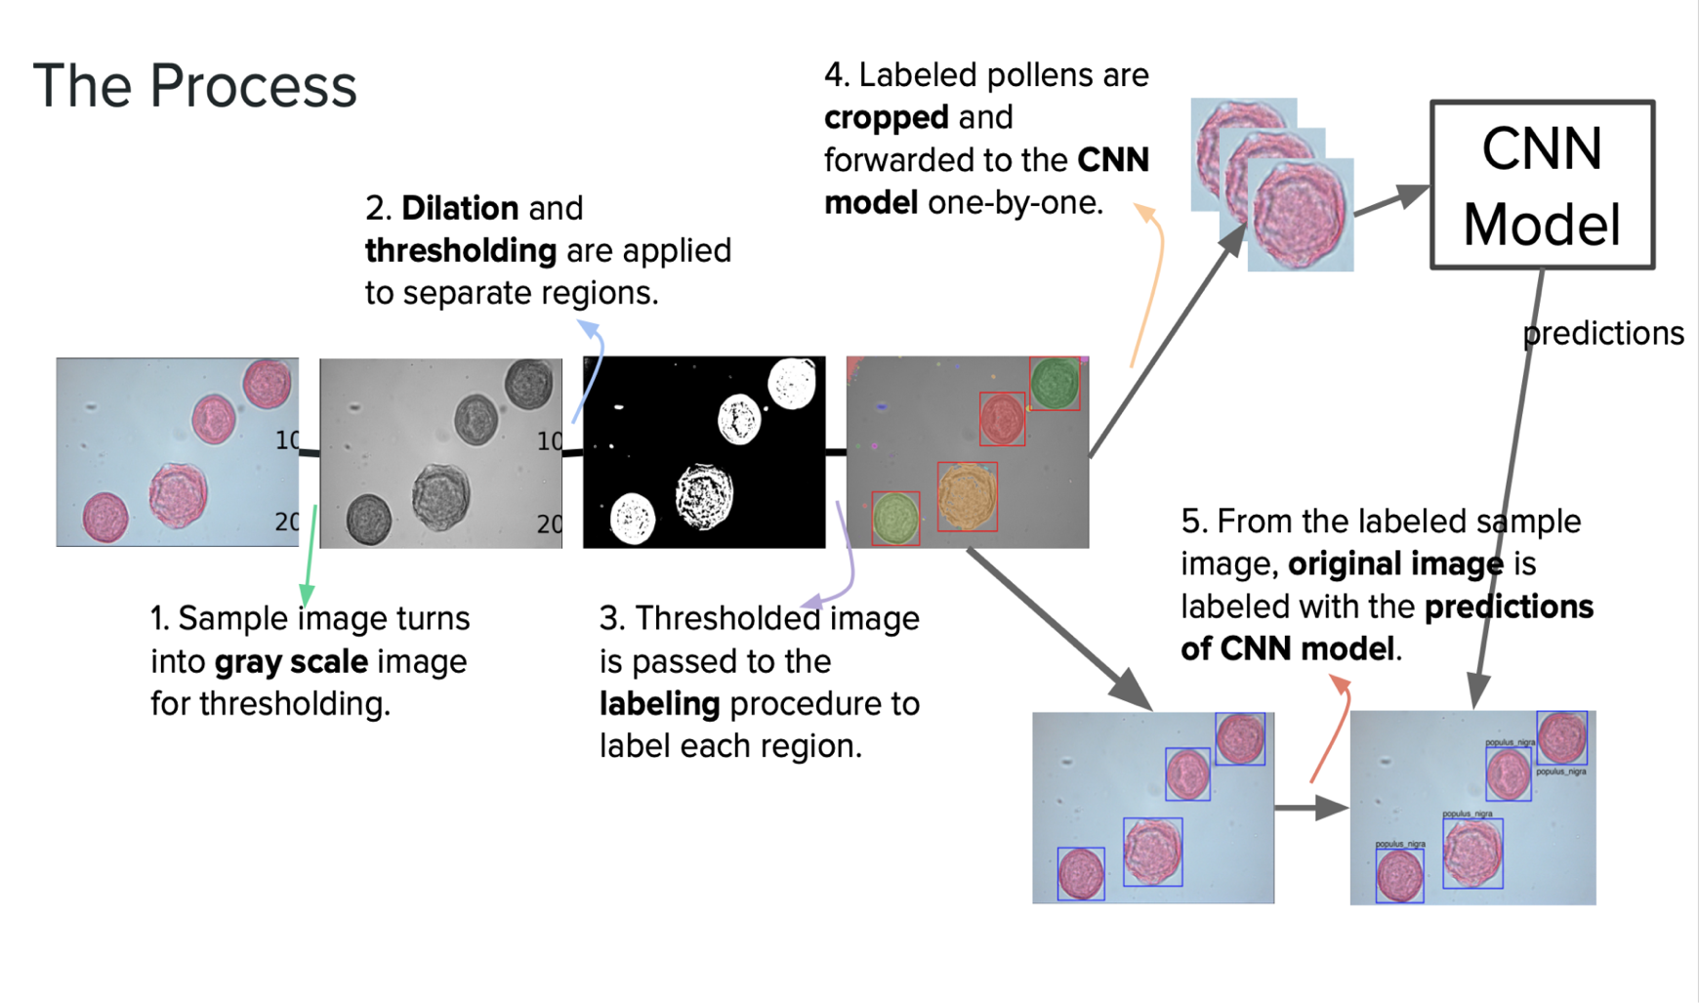

Figure : The Process

# 

# 5. References

[1] “7 ways to reduce server response time,” *Knowledge Base by phoenixNAP*, 24-Jun-2021. [Online]. Available: https://phoenixnap.com/kb/reduce-server-response-time. [Accessed: 26-Feb-2022].

[2] “Global Desktop Browser Market Share for 2022,” *Kinsta®*, 07-Oct-2021. [Online]. Available: https://kinsta.com/browser-market-share/. [Accessed: 26-Feb-2022].

[3] K. Fakhroutdinov, “The Unified Modeling Language,” *UML Diagrams - overview, reference, and examples.* [Online]. Available: https://www.uml-diagrams.org/. [Accessed: 26-Feb-2022].

[4] “Use case diagram,” *Wikipedia*, 30-Oct-2021. [Online]. Available: https://en.wikipedia.org/wiki/Use_case_diagram. [Accessed: 26-Feb-2022].

[5] “UML sequence diagram tutorial,” *Lucidchart*. [Online]. Available: https://www.lucidchart.com/pages/uml-sequence-diagram. [Accessed: 26-Feb-2022].

[6] “Unified modeling language (UML): Activity Diagrams,” *GeeksforGeeks*, 13-Feb-2018. [Online]. Available: https://www.geeksforgeeks.org/unified-modeling-language-uml-activity-diagrams/. [Accessed: 26-Feb-2022].

[7] A. Athuraliya,“What is a deployment diagram: Deployment diagram tutorial,” *Creately Blog*, 27-Sep-2021. [Online]. Available: https://creately.com/blog/diagrams/deployment-diagram-tutorial/. [Accessed: 26-Feb-2022].

[8] “Class diagram,” *Wikipedia*, 08-Dec-2021. [Online]. Available: https://en.wikipedia.org/wiki/Class_diagram. [Accessed: 26-Feb-2022].

[9] “IEEE Reference Guide.” IEEE Periodicals, New Jersey, 12-Nov-2018.

[10] “Pytorch,” *PyTorch*. [Online]. Available: https://pytorch.org/. [Accessed: 26-Feb-2022].

[11] “scikit-image,” *scikit*. [Online]. Available: https://scikit-image.org/. [Accessed: 26-Feb-2022].

[12] “React – a JavaScript library for building user interfaces,” *– A JavaScript library for building user interfaces*. [Online]. Available: https://reactjs.org/. [Accessed: 26-Feb-2022].

[13] *Django*. [Online]. Available: https://www.djangoproject.com/. [Accessed: 26-Feb-2022].

[14] *Google maps platform* . [Online]. Available: https://developers.google.com/maps. [Accessed: 26-Feb-2022].